**//Learning to Program in Visual C# 2010**

//Introduction to .NET Framework

//Andrew Goss- 2014

/*

Windows sits on top of DOS (short for Disk Operating System)

.NET runtime sits on top of Windows, .NET apps require .NET runtime environment

.NET provides an environment that handles data types, memory management, APIs, and more

Object-oriented view of Windows: .NET framework encapsulates lots of functionality into classes

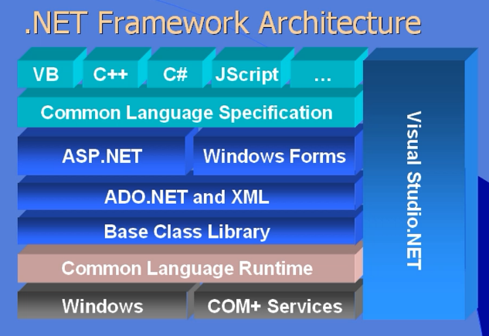

ASP.NET is web applications

Windows forms = client-side (Windows) applications

Python, Cobalt, Fortran all work in the .NET environment. Same set of services and classes

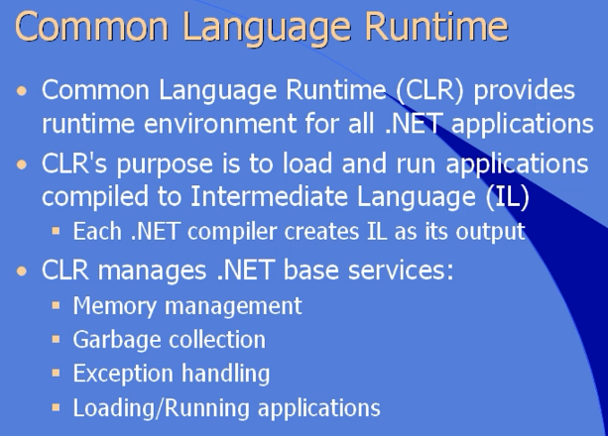

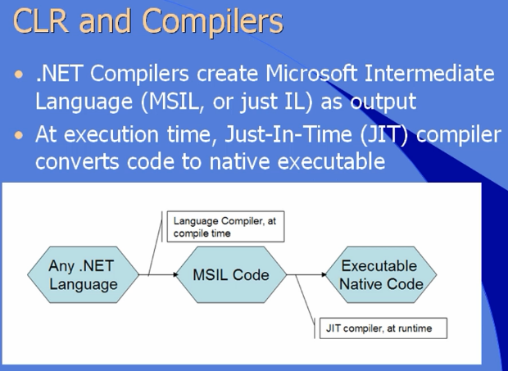

.NET runtime/CLR must be installed on client computers in order to run .NET code

.NET Framework Base Class Library (BCL)

* BCL consists of classes that make your life as a developer easier
* Contains large number of classes (blocks of functionality, including properties, methods, and events) grouped into namespaces
* Each class within namespace has a unique name
* BCL namespaces group classes into common blocks of functionality

Common BCL namespaces

* System (base types strings, ints, date/time, Boolean, math functions, etc.)
* System.data (provides classes for working with data: SQL server, OLE DB, etc.)
* System.diagnostics (event logging, process management, performance counters, tracing, etc.)
* System.globalization (translating applications to work in multiple locales)
* System.IO (moving data from one place to another)
* System.Text (functionality for text encodings)
* System.Text.RegularExpressions (subset of text operations, robust parsing, matching of string data)
* System.Web (design time and run-time for creating and displaying web applications)
* System.Windows.Forms (all features of Windows applications)
* System.XML (XML content (reading and writing))

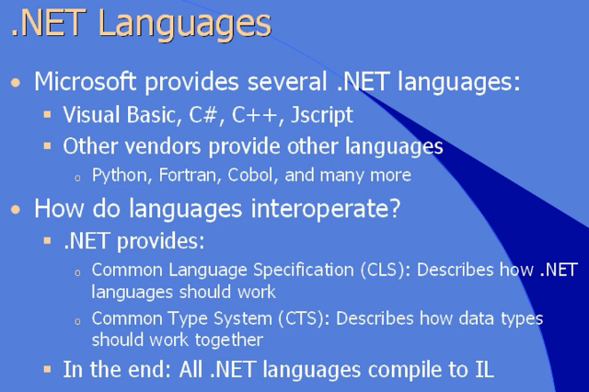

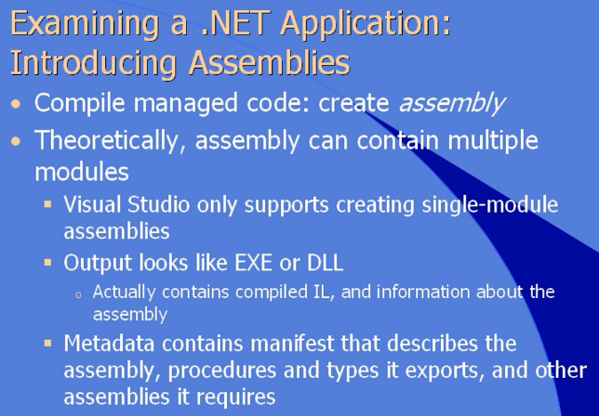

Leftoff:

Introduction to Visual Studio